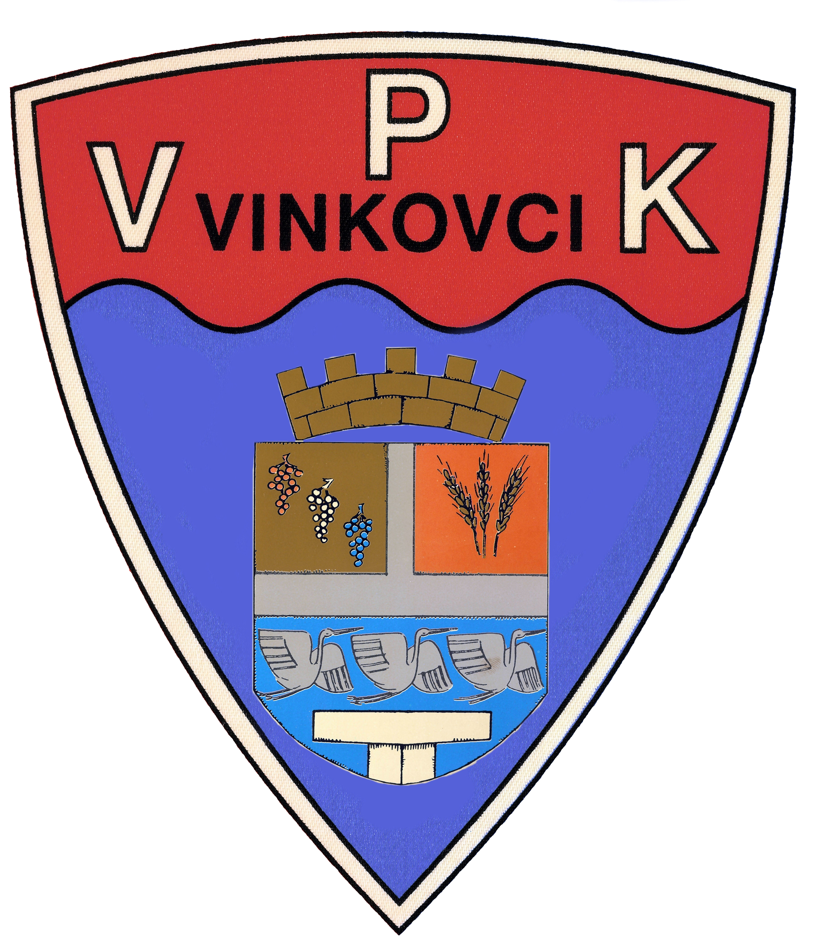 | Vinkovački plivački klub  Slavka Jankovića 7  32100 Vinkovci  www.vpk-vinkovci.hr  vpk.vinkovci@gmail.com | PRIJAVA NATJECATELJA  VINKOVAČKI PLIVAČKI KLUB  VINKOVCI |  | M | X
 |  |  |  | Ž
VRBAS , 13.07.2019.
Ime i Prezime | Godrođ | SLOBODNO |  |  |  |  | PRSNO |  |  | LEĐNO |  |  | LEPTIR |  |  | MJEŠOVITO
Ime i Prezime | Godrođ | 50 | 100 | 200 | 400 | 800/1500 | 50 | 100 | 200 | 50 | 100 | 200 | 50 | 100 | 200 | 100 | 200 | 400
LEON HIBELJIĆ | 2012 | 1.06,15 |  |  |  |  |  |  |  | 1.12,13
LUKA GRGLJANIĆ | 2007 | 35,82 |  |  |  |  | 44,18 |  |  |  |  |  | 50,18
FRAN GRGLJANIĆ | 2010 | 54,03 |  |  |  |  |  |  |  | 59,10
PATRIK KRAMAČEK | 2010 | 53,14 |  |  |  |  |  |  |  | 1.01,36
MARKO PLAVŠIĆ | 2006 | 29.86 | 1.05,00 |  |  |  |  |  |  |  |  |  | 33.21 |  |  |  | 2.45.65
LUKA PLAVŠIĆ | 2011 | 1.02,11 |  |  |  |  |  |  |  | 1.06,77
JAKOV MALETIĆ | 2005 | 43,21 |  |  |  |  | 53,37
KRISTIJAN ROHALJ | 2009 | 43.94 | 1.30.06
JAKOV SVETIĆ | 2010 | 46,62 |  |  |  |  |  |  |  | 53,11
MARIN PERUNSKI | 2006 | 37.85 |  |  |  |  |  |  |  | 40.94
NIKOLA PERUNSKI | 2009 | 50,62 |  |  |  |  |  |  |  | 58,46
JAKOV BOŽIĆ | 2008 | 38.87 |  |  |  |  | 49.47
BORIS OSTOVIĆ | 2006 | 33,63 | 1.12.96 |  |  |  |  |  |  |  |  |  | 39.67
LOVRO LOLIĆ | 2008 | 54,22 |  |  |  |  |  |  |  | 54,21
ANDREJ ŽIVKOVIĆ | 2008 | 56,54 |  |  |  |  |  |  |  | 1.03,41
MATEJ ŽIVKOVIĆ | 2008 | 54,12 |  |  |  |  |  |  |  | 1.02,36
Ime i Prezime | Godrođ | SLOBODNO |  |  |  |  | PRSNO |  |  | LEĐNO |  |  | LEPTIR |  |  | MJEŠOVITO
Ime i Prezime | Godrođ | 50 | 100 | 200 | 400 | 800/1500 | 50 | 100 | 200 | 50 | 100 | 200 | 50 | 100 | 200 | 100 | 200 | 400
FRAN BUDIMIR | 2006 |  | 1.08.76 |  |  |  | 38.57 |  |  |  |  |  | 33.65 |  |  |  | 2.45.75
JURICA DRAGUN | 2006 |  | 1.08.76 |  |  |  | 38.57 |  |  |  |  |  | 33.65 |  |  |  | 2,45,75
FILIP PUCE | 2006 | 34,21 |  |  |  |  | 45,52 |  |  | 38,78
PATRIK PUCE | 2008 | 41,52 |  |  |  |  |  |  |  | 47,56
ANTONIO PIPERKOVIĆ | 2003 | 32,21 |  |  |  |  | 38,52 |  |  |  |  |  |  |  |  |  | 2,50,35
DOMAGOJ ŠEGO | 2004 | 29,00 | 1,03,23 |  |  |  | 38,52
DAMIR SUKOP | 2002 | 32,85 |  |  |  |  | 42,89 |  |  | 37,97
BRUNO ĆORIĆ | 2010 | 45,18 | 1,29,65 |  |  |  |  |  |  | 47,50 |  |  | 50,84
MARIN PINTER | 2011 | 58,12 |  |  |  |  |  |  |  | 1.02,54
TOMO PETRINIĆ | 2009 | 33,58 |  |  |  |  | 47,81 |  |  | 42,12 |  |  | 40,69
LEON ČUGURA | 2002 | 29,85 |  |  |  |  | 40,29 |  |  | 35,24
LUKA GUGIĆ | 2005 | 31,85 |  |  |  |  | 45,69 |  |  | 34,32 |  |  | 39,29
GABRIEL PETRIČEVIĆ | 2008 | 38,59 |  |  |  |  | 48,56 |  |  | 44,25
LUKA MARIJANOVIĆ | 2010 | 1.03,44 |  |  |  |  |  |  |  | 1.08,14
DAVID SUKOP | 2008 | 51,34 |  |  |  |  |  |  |  | 58,14
LUKA DOŽIĆ | 2010 | 1.01,01 |  |  |  |  |  |  |  | 1.12,94
DORA VRSELJA | 2008 | 47,24 |  |  |  |  |  |  |  | 56,13
DUNJA KAPIDŽIĆ | 2010 | 51,38 |  |  |  |  |  |  |  | 1.09,12
NIKA CAJNER | 2010 | 44,27 |  |  |  |  | 57,77 |  |  | 52,12
NENSI VIDINOVIĆ | 2011 | 48,96 |  |  |  |  | 1,08,25 |  |  | 55,42 |  |  | 58,25
ELENA VIDINOVIĆ | 2007 | 41,01 |  |  |  |  | 59,47 |  |  | 54,28
BRIGITA VIDINOVIĆ | 2004 | 29,80 | 1,14,37 |  |  |  |  |  |  | 34,23
UNA VIDEKOVIĆ | 2011 | 44,22 |  |  |  |  |  |  |  | 51,24 |  |  | 55,27
NIKA BRDAR | 2003 | 29,27 | 1,03,00 |  |  |  |  |  |  | 33,38 |  |  | 31,76

ŠTAFETE: | SLOBODNO | 4X50 |  | 4X100 |  | 4X200 |  | MJEŠOVITO | 4x50 |  | 4X100 |  | 4x200

