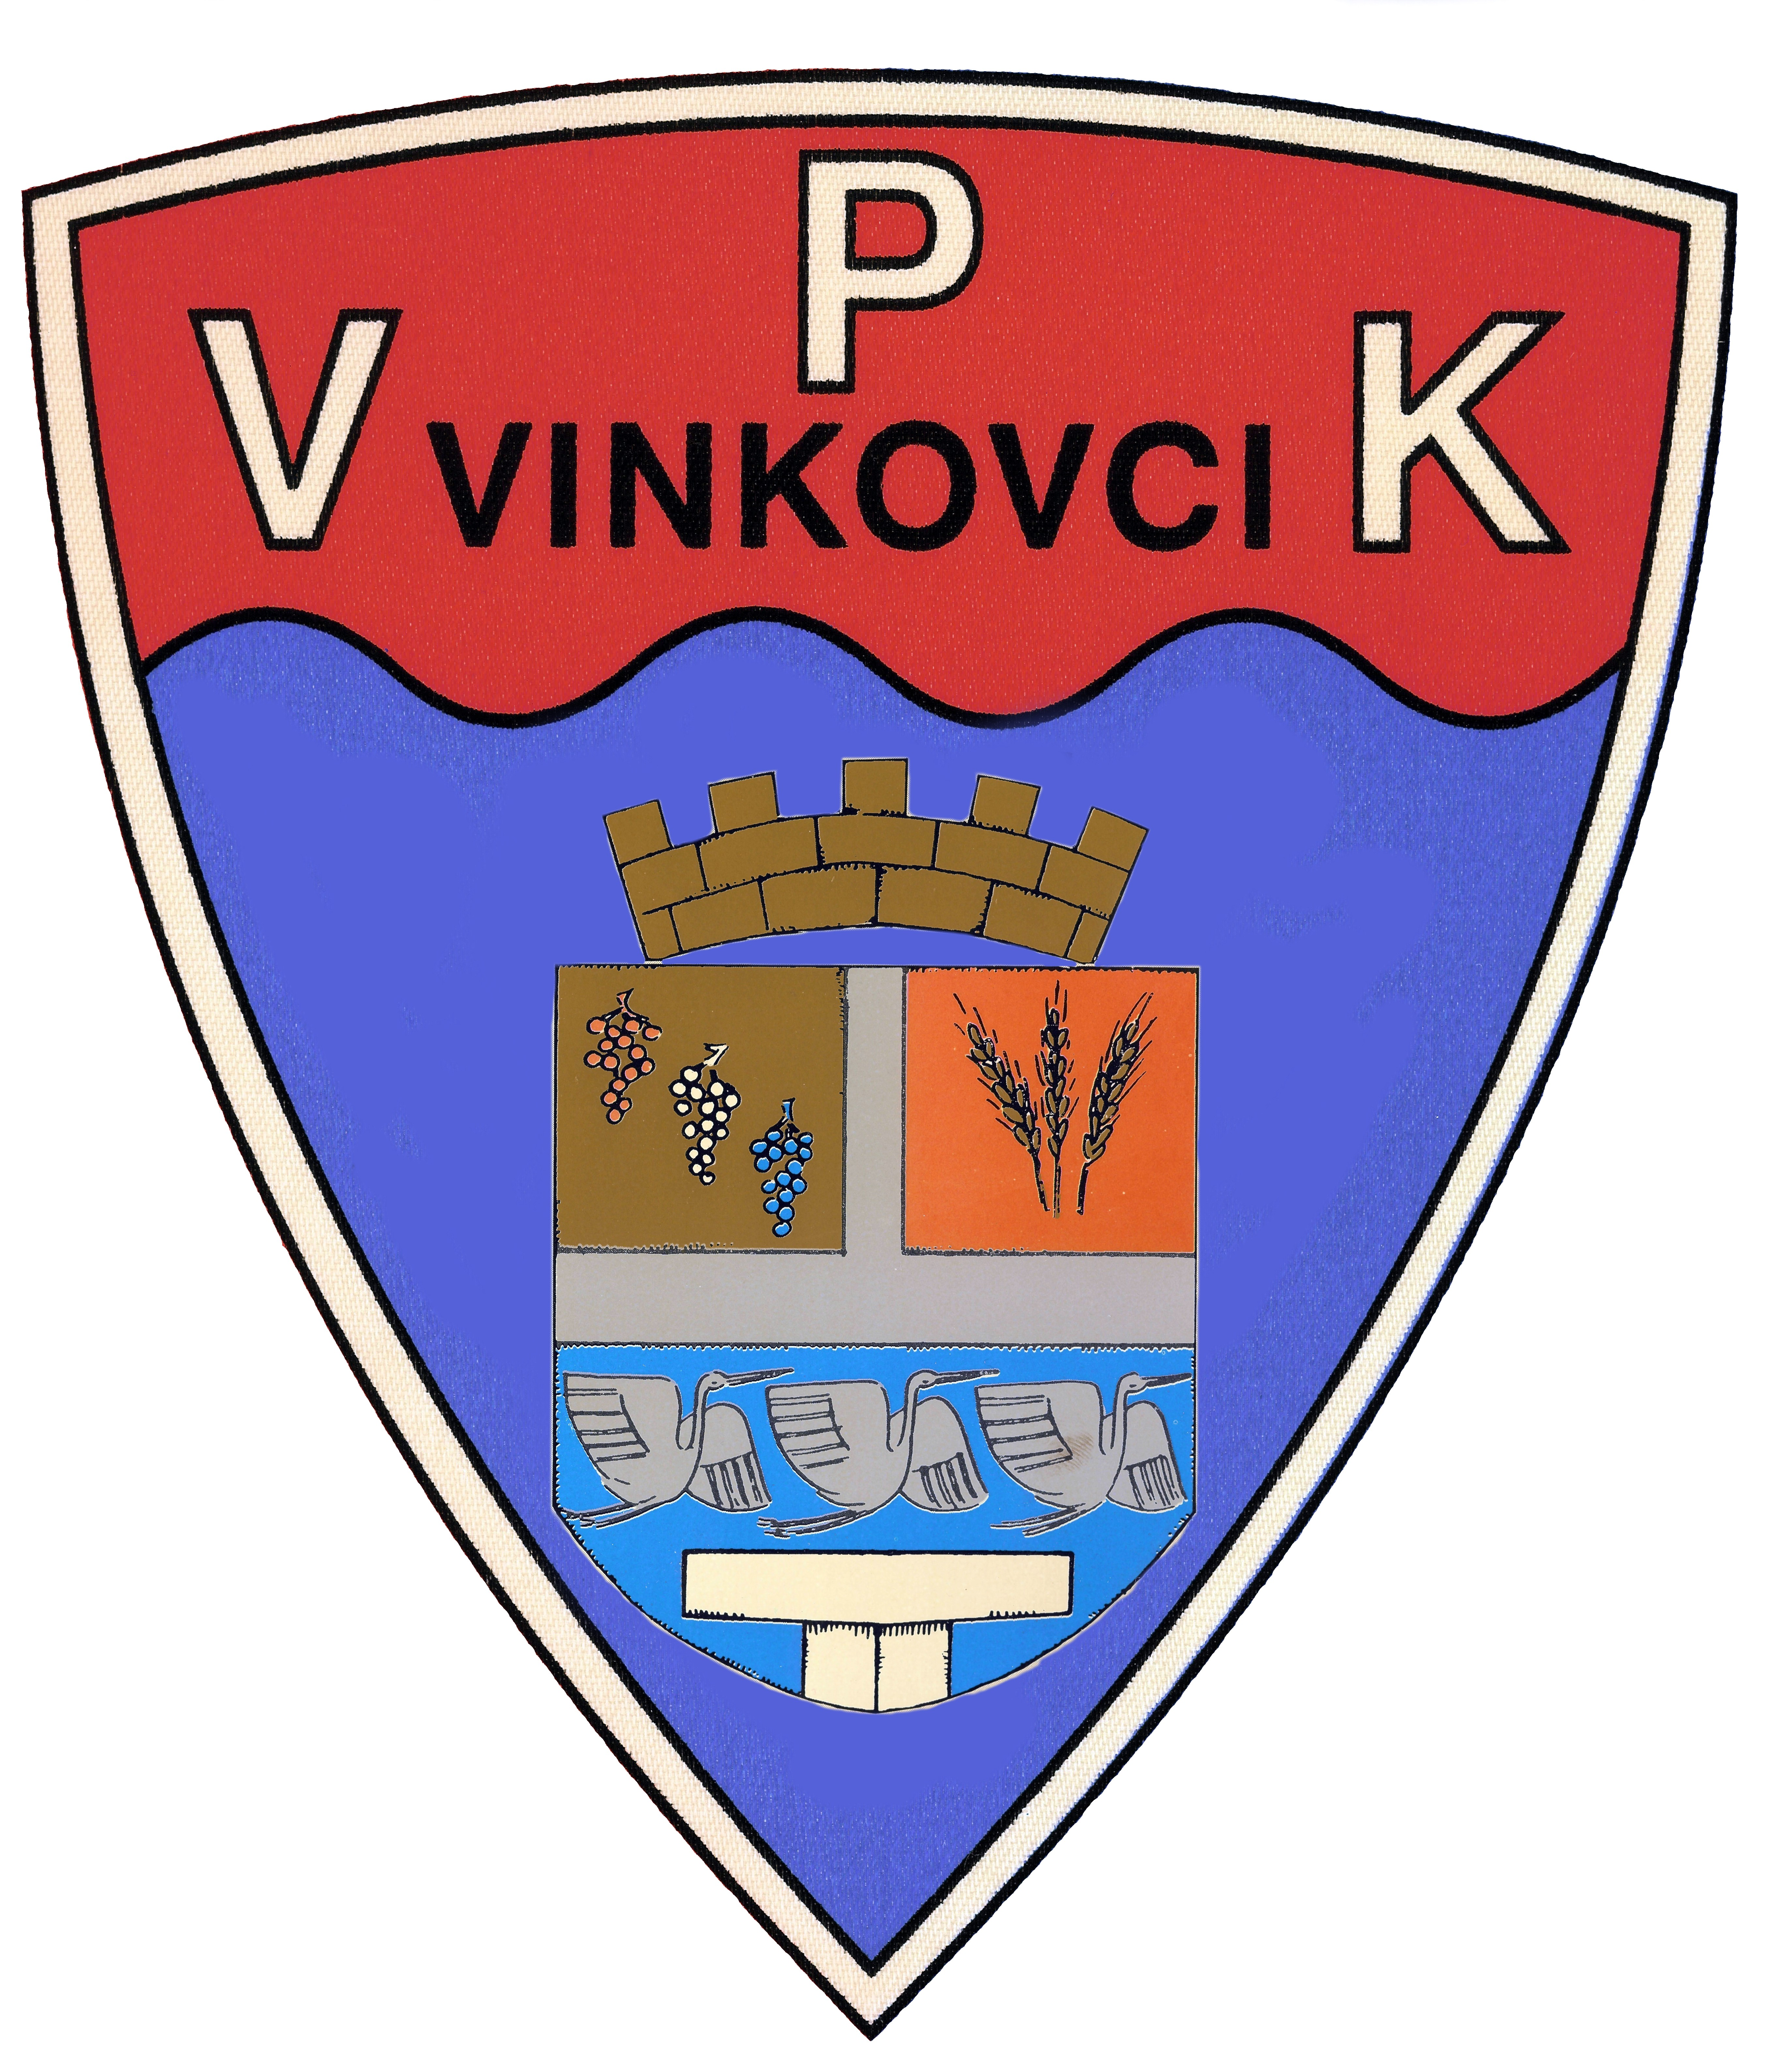 | Vinkovački plivački klub  Slavka Jankovića 7  32100 Vinkovci  www.vpk-vinkovci.hr  vpk.vinkovci@gmail.com | ENTRY FORM  VINKOVAČKI PLIVAČKI KLUB |  | M
 |  |  |  | F
SOMBOR KUP BRATSKIH GRADOVA 09.03.2019.
First name, Last name | Year of birth | Freestyle |  |  |  |  | Breststroke |  |  | Backstroke |  |  | Butterfly |  |  | IM
First name, Last name | Year of birth | 50 | 100 | 200 | 400 | 800/1500 | 50 | 100 | 200 | 50 | 100 | 200 | 50 | 100 | 200 | 100 | 200 | 400
LUKA PLAVŠIĆ | 2011. | 55:00 |  |  |  |  |  |  |  | 59:00
BRUNO ČORIĆ | 2010. | 42:00 |  |  |  |  | 1:05:00 |  |  | 44:00
GABRIJEL PETRIČEVIĆ | 2008. |  | 1.31,38 |  |  |  |  | 1.49,42 |  |  |  |  |  |  |  | 1.47,64
MATKO BOŽIČEVIĆ | 2009. |  | 1:35:00 |  |  |  |  |  |  |  | 1:50:00 |  | 1:05:00
LOVRO LOLIĆ | 2008. |  | 1:46:00 |  |  |  |  |  |  |  | 1:55:00
PETAR KNEZ | 2009. |  | 1:30:00 |  |  |  |  | 2:10:00 |  |  | 1:47:00
LUKA GRGLJANIĆ | 2007. |  | 1.25,13 |  |  |  |  | 1.41,07 |  |  |  |  |  |  |  | 1.41,07
NIKOLA PERUNSKI | 2009. |  | 1:30:00 |  |  |  |  | 2:10:00 |  |  | 1:47:00
TONI SCHWEIZER | 2011. | 49:00 |  |  |  |  |  |  |  | 52:00 |  |  | 1:10:00
TOMO PETRINIĆ | 2009. |  | 1.18,67 |  |  |  |  |  |  |  | 1.26,71 |  |  |  |  | 1.31,27
FLAVIJAN DUJIĆ | 2010. | 44:00 |  |  |  |  | 59:00 |  |  |  |  |  | 1:10:00
MIHAEL UZUNIĆ | 2010. | 56:00 |  |  |  |  |  |  |  | 59:00
JAKOV SVETIĆ | 2010. |  |  |  |  |  | 59:00 |  |  | 52:00 |  |  | 1:05:00
LUKA DOŽIĆ | 2010. | 50:00 |  |  |  |  | 1:05:00 |  |  | 55:00
JAKOV BOŽIĆ | 2008. |  | 1.38,26 |  |  |  |  | 2.02 |  |  |  |  |  |  |  | 2.10
TONI KOVAČEVIĆ | 2013, | 59:00 |  |  |  |  |  |  |  | 1:05:00
IVAN KOVAČEVIĆ | 2010. | 41:00 |  |  |  |  |  |  |  | 44:00 |  |  | 1:05:00
DUNJA KAPIDŽIĆ | 2010. | 51:00 |  |  |  |  |  |  |  | 58:00
UNA VIDEKOVIĆ | 2011. | 45:00 |  |  |  |  | 1:00:00 |  |  |  |  |  | 51:00
LARA BARIĆ | 2010. | 50:00 |  |  |  |  | 1:00:00 |  |  | 54:00
ELENA VIDINOVIĆ | 2007. |  | 1:35:00 |  |  |  |  | 1:50:00 |  |  |  |  |  |  |  | 1:40:00
NENSI VIDINOVIĆ | 2011. | 50:00 |  |  |  |  |  |  |  | 55:00 |  |  | 1:10:00
NIKA CAJNER | 2010. | 47:00 |  |  |  |  | 59:00 |  |  |  |  |  | 1:00:00
LEONARDA KOMAREC | 2009. |  | 1:35:00 |  |  |  |  |  |  |  | 1:45:00 |  | 1:05:00
DORA VRSELJA | 2009. |  |  |  |  |  | 2:00:00 |  |  |  | 1:45:00 |  | 1:05:00
ANA DAMJANOVIĆ | 2008. |  | 1:30:00 |  |  |  |  | 1:47:00 |  |  |  |  |  |  |  | 1:39:00

RELAY: | FREESTYLE | 4X50 |  | 4X100 |  | 4X200 |  | MEDLEY | 4x50 |  | 4X100 |  | 4x200

